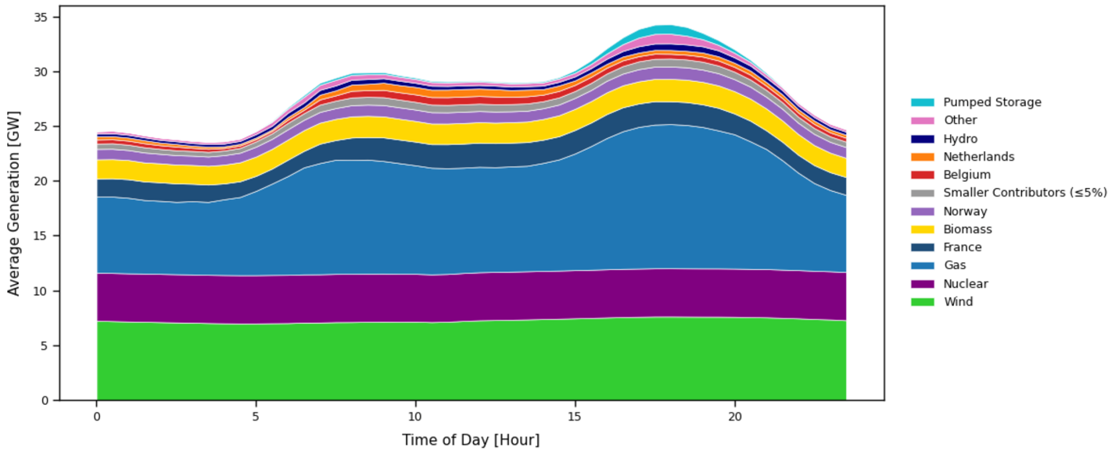
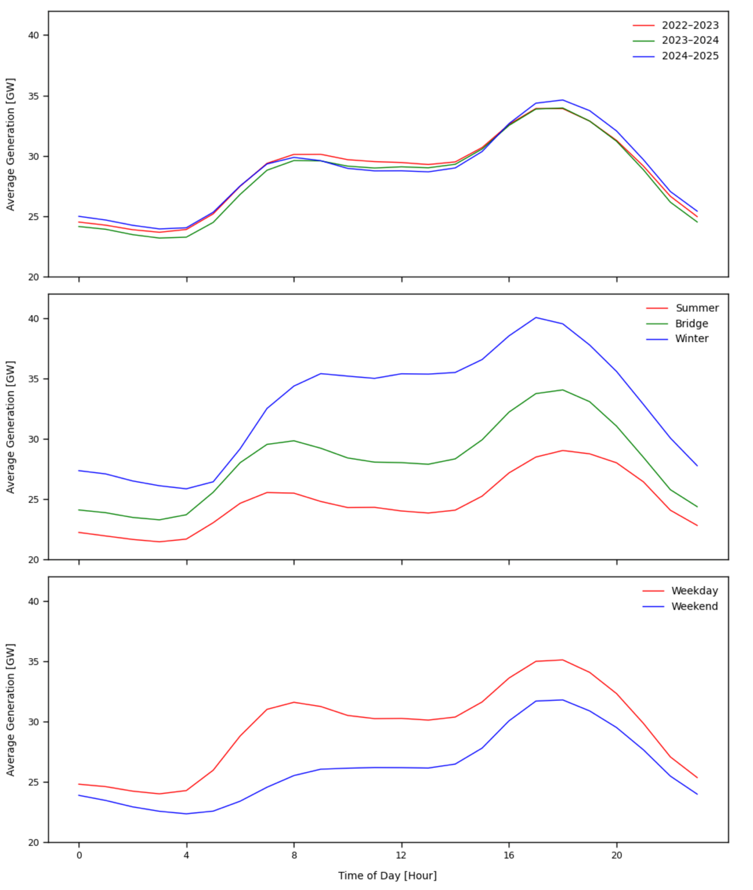
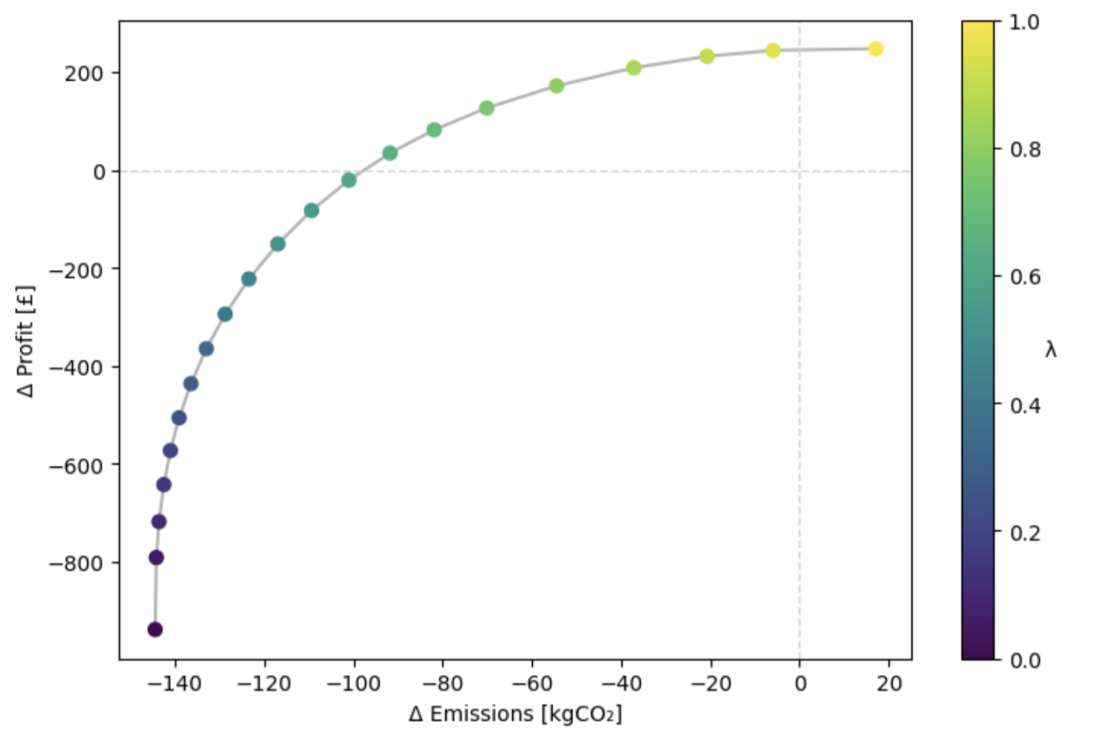
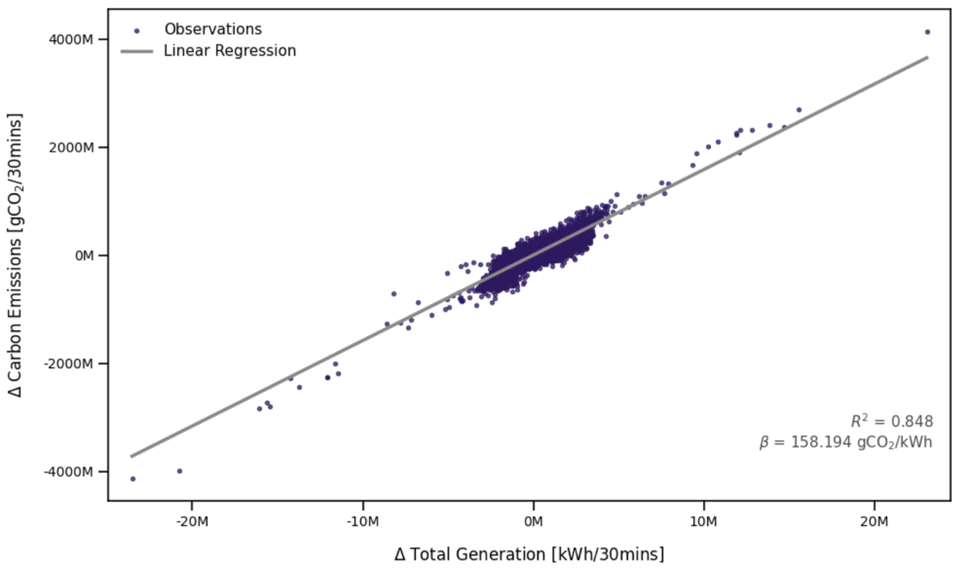
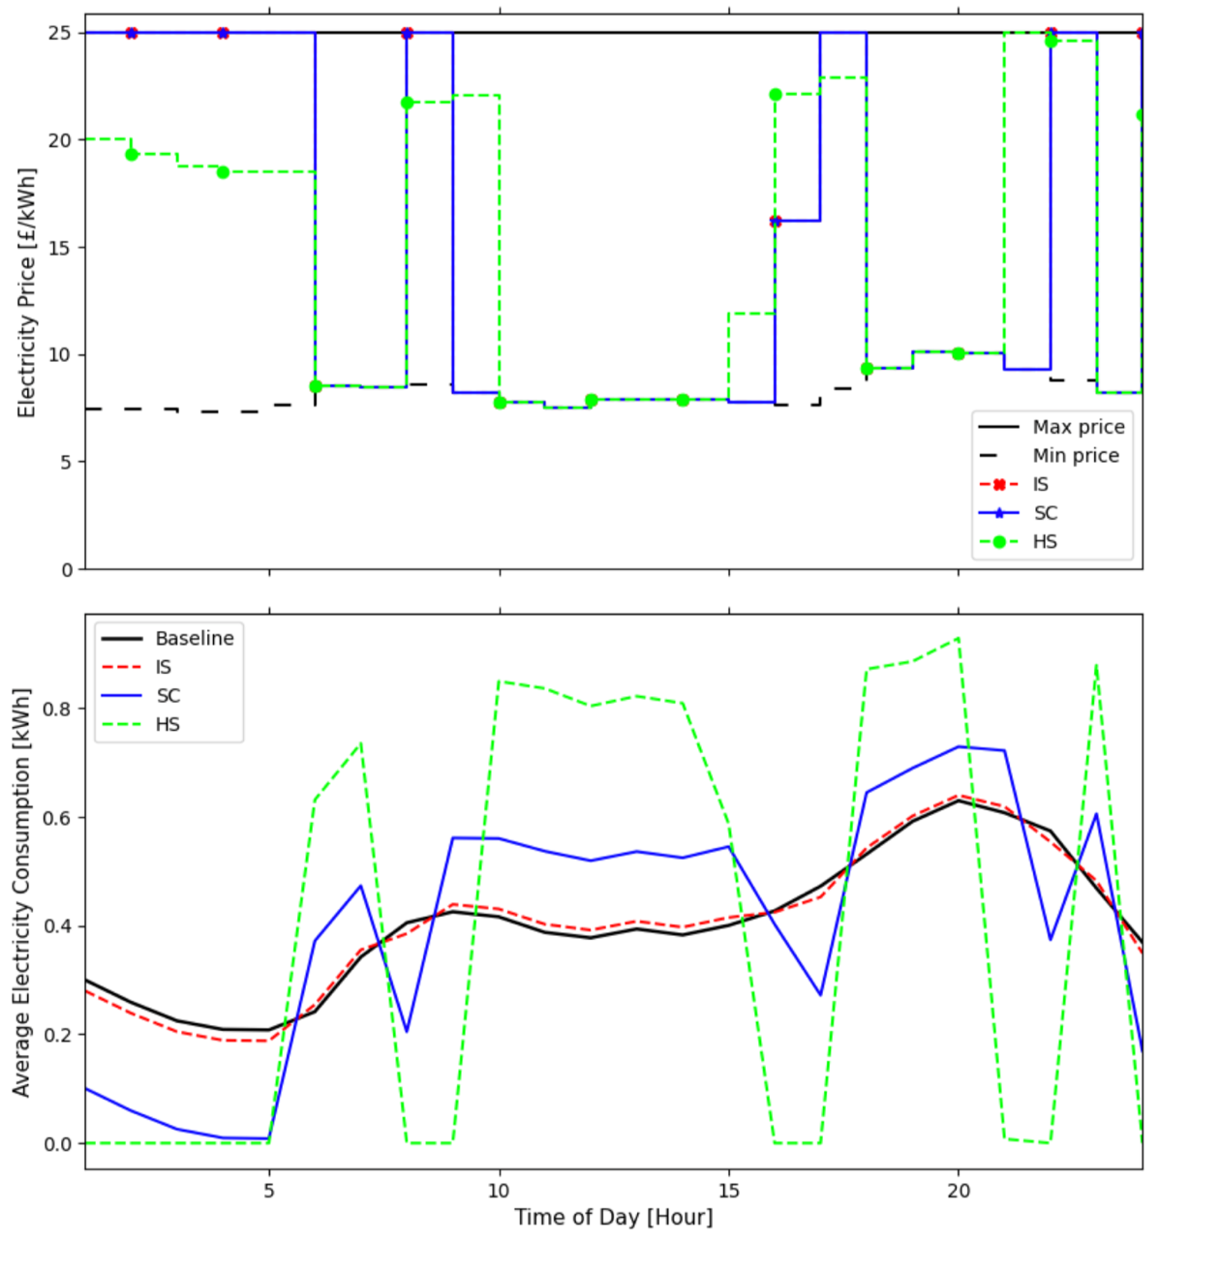
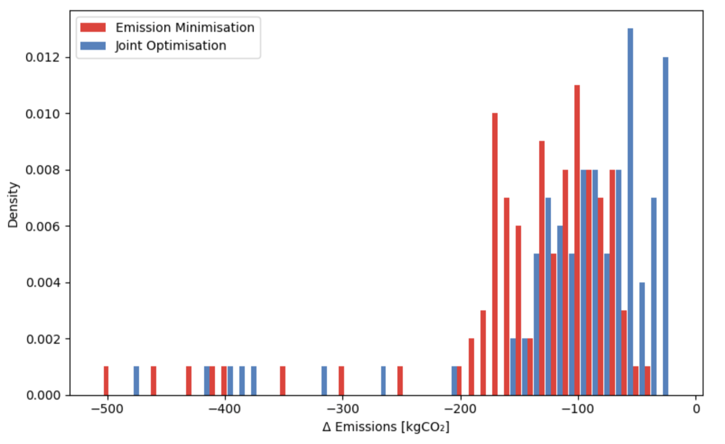
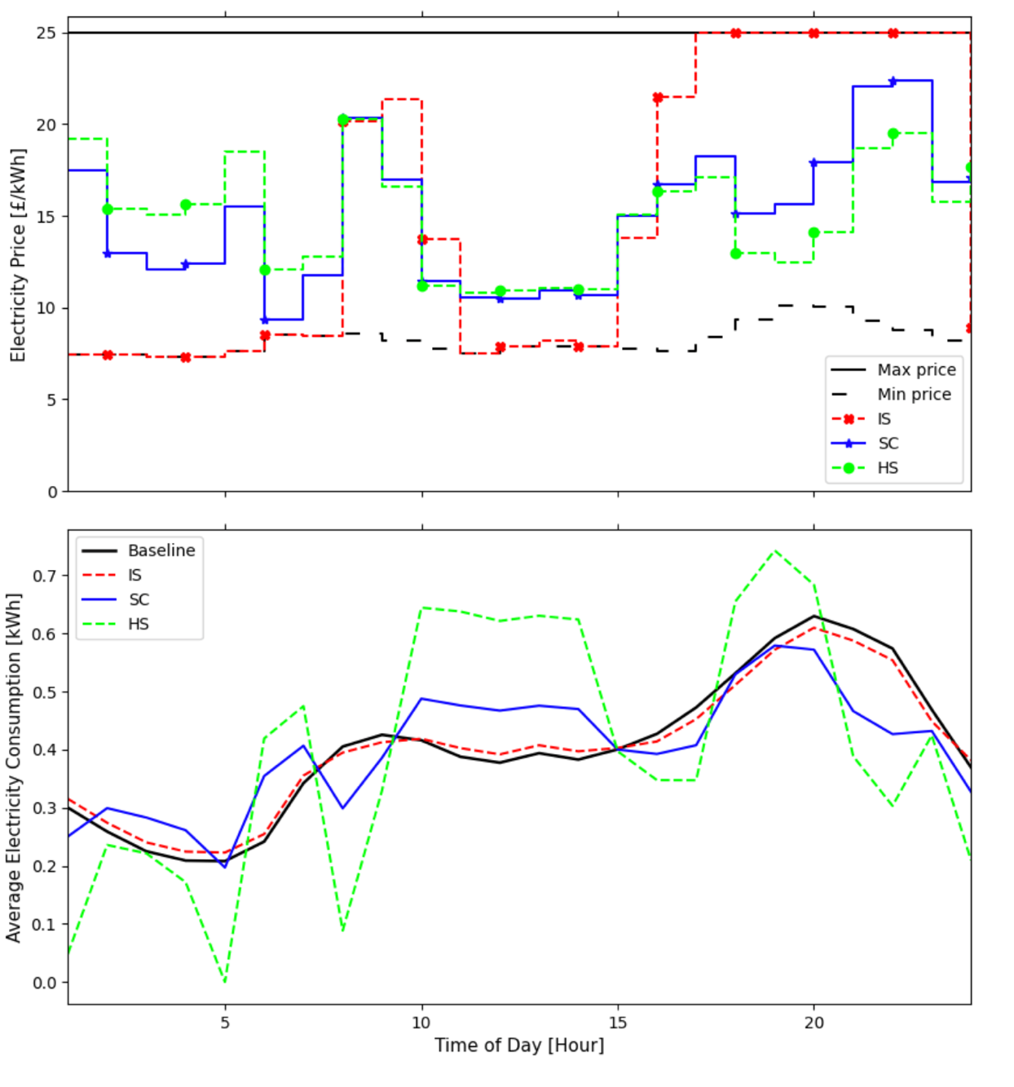

Potential explanation for this
- One explanation for this opportunity for mutual benefit is that objectives take the most gain from different consumers. (Use figure 6d for this)
- IS consumers offer limited potential gain to reducing emissions because they inflexible. Their carbon footprint will be the same regardless of price.
- Emissions require flexible consumers who responds to changes and therefore consumer energy when MEFs are lower
- In contrast, for the profit maximiser, inelastic consumers provide the most potential for profit increases because retailers can raise the profit margin and still receive the same level of demand
- This discrepancy between how both objectives are achieved through PBDR is likely to explain why the results exhibit a significant level of compatability.
- This means that multiple dynamic r
